ME322: Machine Design

Mini Project

***Sun Tracking Solar Panel with Arduino Mechanism***



***Team 16: Doofenshmirtz Inc.***

**By**

***Varenya Tiwari - 190103122***

***Thengadi Bhavesh Sanjay – 190103099***

***Patil Ritu Nilkanth – 190103066***

***Vanshaj Wore – 190103101***

***Shreya Singh - 190103092***

**Contents**

|  |  |  |
| --- | --- | --- |
| **SI no.** | **Contents** | **Page** |
| 1 | Background of the Problem | 3 |
| 2 | Need Analysis & Motivation | 4 |
| 3 | Project Goal Statement | 4 |
| 4 | Calculation | 5 |
| 5 | Material Selection | 9 |
| 6 | Specifications | 13 |
| 7 | Control System | 14 |
| 8 | Simulation | 15 |
| 9 | CAD Model | 18 |
| 10 | Cost Analysis | 22 |
| 11 | Application / Market | 22 |
| 12 | Conclusion | 23 |

1. **Background of the Problem :**

In today’s world, energy demand is growing at an accelerating rate and a nation’s growth largely depends on energy production and conservation. With increasing and ever expanding economy, population, urbanization and industrialization energy production is a major concern and due to associated adverse environmental effects due to traditional methods of energy production everyone is looking towards renewable and green sources of energy production, solar being the most sought after due to its wide applications, availability and ease of use.

Utilization of solar energy for electricity production is primarily addressed by large scale installations of fixed solar panels to capture sunlight during daytime. Even now small scale application of solar panels for electricity production is not widespread due to less power generation by small size solar panels. To address this problem sun tracking mechanisms are being installed to solar panels to increase their performance and it’s been observed that in optimal conditions a sun tracking solar panel can generate upto 40% more power than static solar panels.

Sun tracking solar panels are available in single axis and double axis mechanisms, with double axis being more efficient than single axis mechanisms providing more exposure to sunlight. These functionalities are achieved through various mechanisms both active continuous tracking mechanisms and passive mechanisms which are less efficient since they don’t respond to sun movement directly but instead use some different aspect associated with sun movement.

1. **Need Analysis & Motivation :**

The motivation for the project came from the social relevance of solar energy. Amid a global energy crisis, instruments such as solar panels need to be used to their highest potential. Therefore, there is a substantial need for methods that can optimize their energy collection. One of these methods is the use of solar tracking systems, which is a device that will vertical and horizontally adjust a solar panel, so it may maintain a perpendicular relationship with direct sunlight. In turn, it will generate more electricity than a standard, fixed solar panel.

1. **Project Goals :**

The goal of the project is to design a sun tracking mechanism that allows a solar panel to actively follow a light source. In order to do this there are a number of problems that needs to be solved, mainly:

* Efficient sun tracking and moving the solar panel accordingly
* Making the model scalable and less power consuming to rotate the panels
* Making model self-sufficient so it doesn’t require any external power source for operation.
* Material selection to provide model strong durability and resistance to environmental conditions
* Making small size products to address different utilities like street lights and increasing efficiency through improved mechanism.

1. **Calculation :**
   1. **Degree of rotations :**

Given that the sun moves at 15 degrees per hour and assuming, the tracker would make position changes every .01

Seconds, the change in angular velocity for vertical position is calculated. The horizontal position will adjust based on tracker placement.

Rotation of Sun (Δθ): **15 degrees/hr[1]**

Position changes of tracker every: **0.01 seconds**

Assuming **Δt = 0.05 secs,**

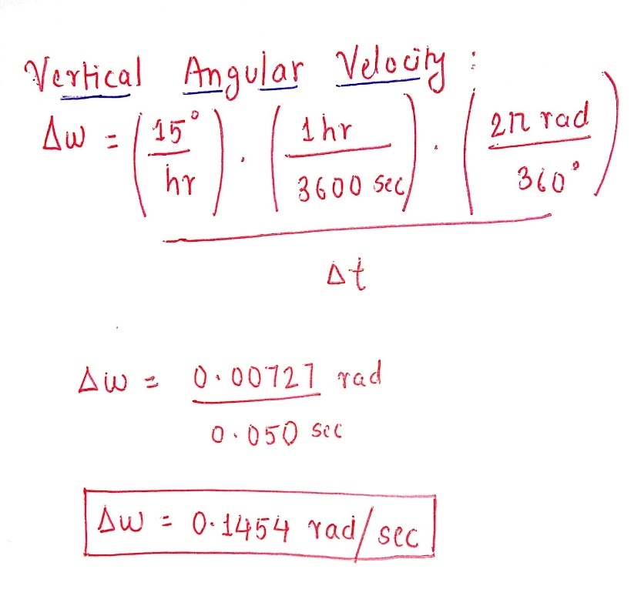

Angular velocity Δw for vertical axis: **0.1454 rad/sec**

* 1. **Energy Generation :**

Area of Photovoltaic Panel: **2836.28 cm²**

PV rating: **50 watts /sq.ft.hr**

Assumption: The solar panel is always perpendicular to the sunrays.

Let,

T = **7.49 hours** (Average sunlight hours/day in India annually)

For static tracker:

**Average energy generated per day: 1123.5 W**

For dual axis tracker:

**Average energy generated per day: 1415.273 W**

**Efficiency = [(Power) tracker - (Power) static]/(Power)static**

= [(1415.273 W - 1123.5 W)/ (1123.5 W)] *100

= 25.97%

* 1. **Torque :**

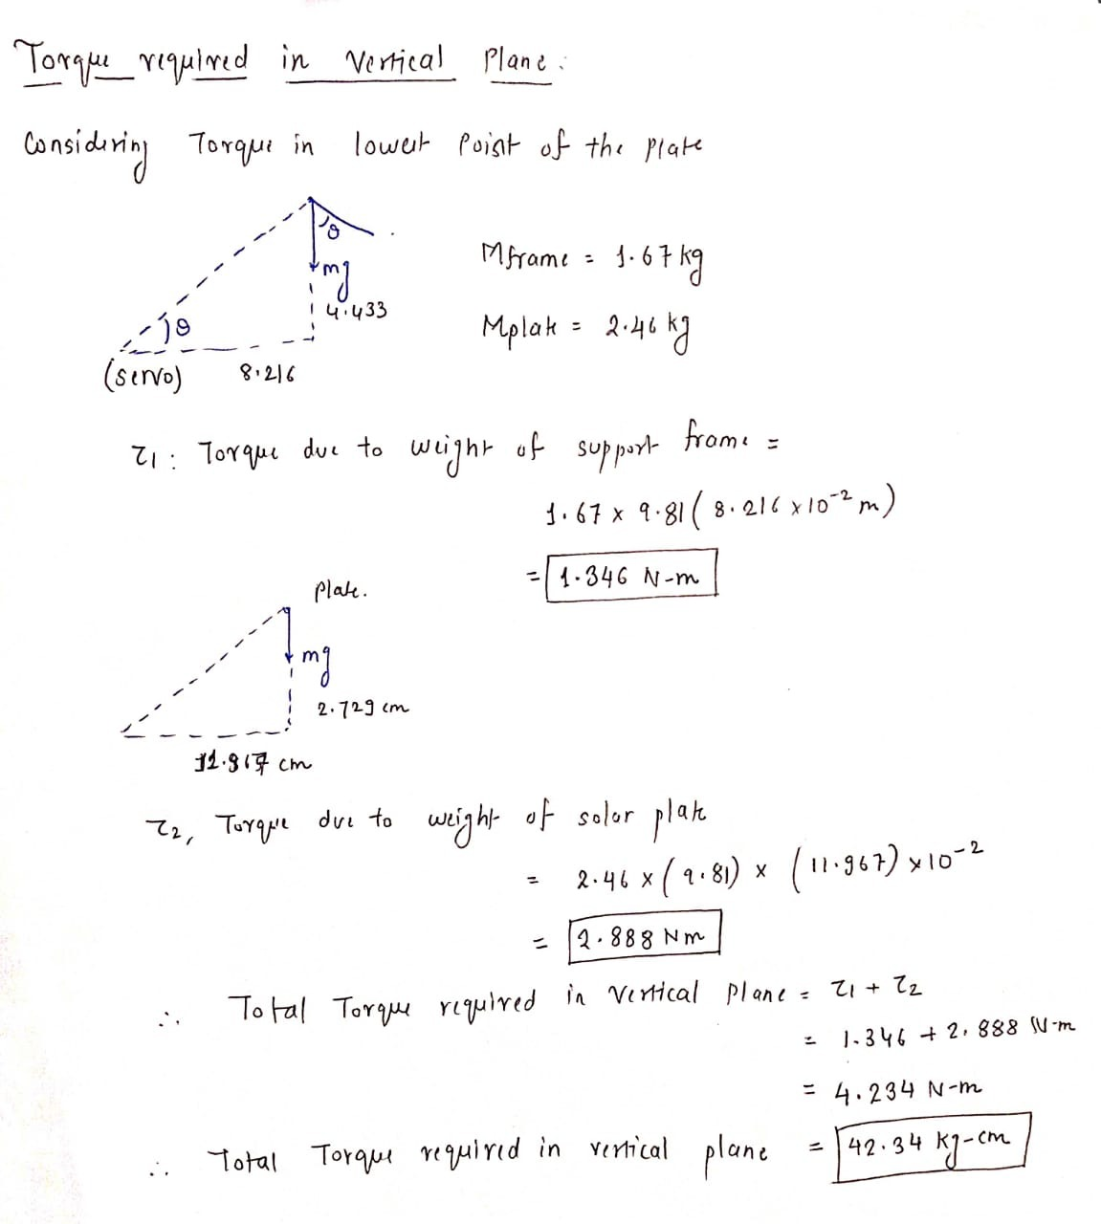

* 1. **Degree of freedom :**

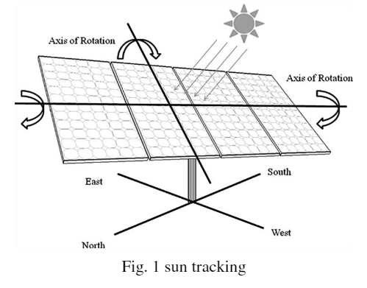

* Dual-axis trackers have **two degrees** of freedom that act as axes of rotation.
* The axes are typically perpendicular to each other such as those in the altazimuth system.
* i.e., **Azimuthal (Vertical Axis) and Polar (Horizontal Axis)**
* The panel rotates a full **360** degrees around the azimuth (vertical) axis
* The panel tilts from **5 to 135** degrees with the polar (horizontal) axis
  1. **Weight of framework :**

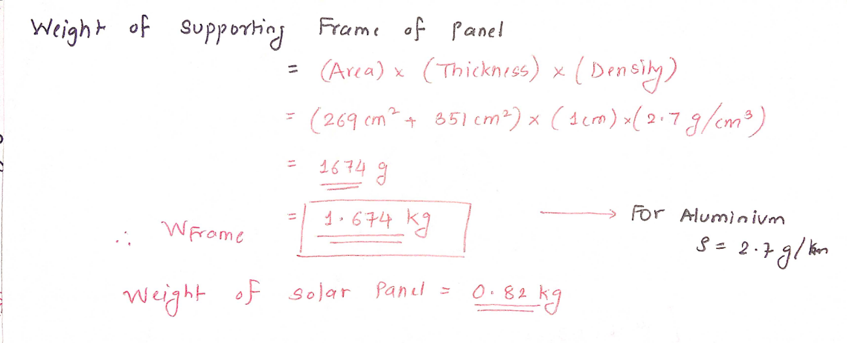

Hence, weight of the Frame is **1.674 kg**

Weight of the panel is **2.46 kg**

* 1. **Angle of inclination calculation:**

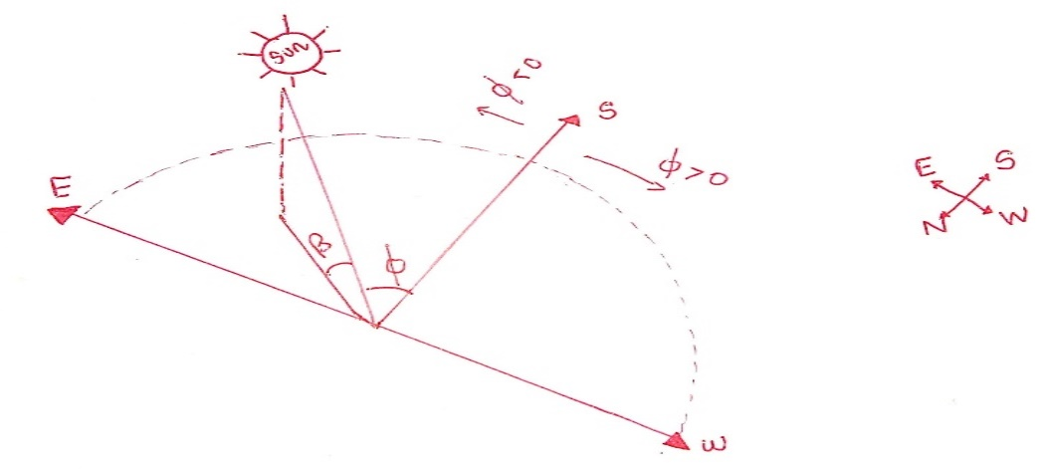

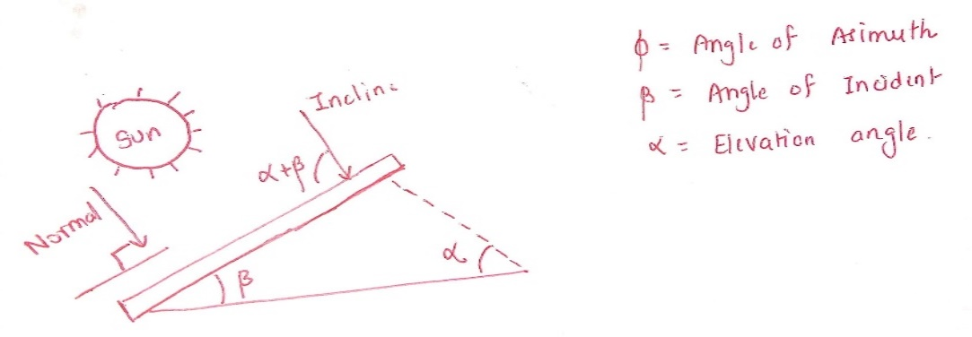

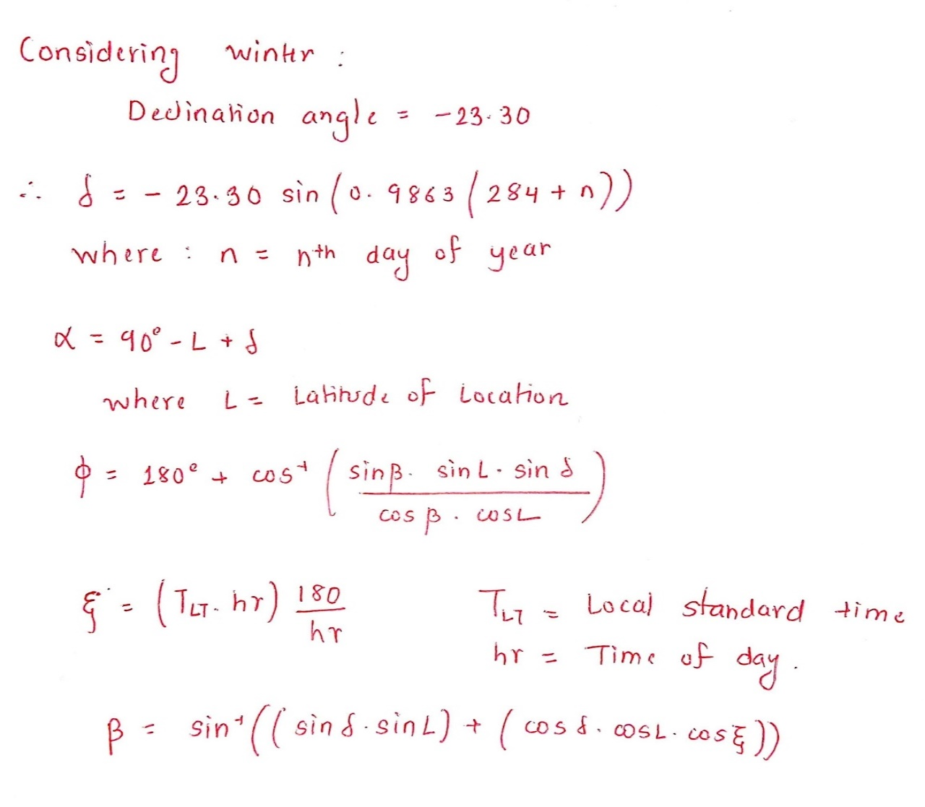

1. **Material Selection :**

The sun tacking solar panel model like every other design task has a few key parameters that determine the overall usability of the product. The parameters that are most crucial for our design have been identified as follows:

* + *Solar Panel*
  + *Framework Material*
  1. **Solar Panel Material :**

Many different choices of solar panels are available in market based on specific requirements a brief comparison of different solar panels we considered during our study are mentioned below:

|  |  |  |
| --- | --- | --- |
| **Type** | **Advantages** | **Disadvantages** |
| *PERC* | Requires least space  Most efficient  Highest power capacity | Most expensive initially  Some earlier panels suffered from light and elevated temperature induced degradation |
| *Monocrystalline* | Less expensive alternative to PERC panels without the passivating layer | High initial cost  Low yield in the manufacturing process |
| *Polycrystalline* | Middle option in terms of cost, efficiency and power capacity | Low heat tolerance  Not suitable in hot environments |
| *Thin-Film* | Lowest cost  Easier to install | Shorter lifespan than crystalline panels  Requires more space  Least efficient |

Based on our requirements of solar panel to be highly efficient in energy conversion rate, be able to setup in a small space and are able to tolerate environmental damages. **PERC solar panels** has been considered for the proposed model.

* 1. **Framework Material :**

Considering the ease of availability and manufacturing, various material alternatives have been considered for our design. A few key properties were identified for the material performance and relative scores were awarded to the materials.

The key parameters are as follows:

1. ***Durability*** - It should be durable for at least a span of 5 years.
2. ***Strength*** - It should be strong enough to withstand environmental conditions.
3. ***Weight*** - It should contribute no more than 2-3 kg to the total weight of the bot.
4. ***Cost*** – The cost should be minimal considering the easy availability of raw material.

|  |  |  |
| --- | --- | --- |
| **Sr. No** | **Advantages** | **Disadvantages** |
| *Aluminium* | Provides a good strength to density ratio compared to some other materials | In certain scenarios, the strength might fall short and might lead to failure in extreme conditions |
| *Steel* | Extremely strong and with certain alloys corrosion can be avoided | Steel is a relatively heavy material |
| *Titanium* | High strength and durability | Titanium is a heavy material and also relatively expensive |
| *Carbon Fibre* | Carbon Fibre provides the highest strength with the lowest weight | The cost of carbon Fibre is extremely high |

The score chart for various materials has been prepared below and points (weightage) has been allotted according to the requirements of the bot and the conditions of use.

|  |  |  |  |  |  |
| --- | --- | --- | --- | --- | --- |
| ***Parameter*** | **Titanium** | **Carbon**  **Fibre** | **Aluminium** | **Steel** | **Weightage** |
| *Durability* | 9 | 9.5 | 8 | 6 | 0.25 |
| *Strength* | 9 | 8.5 | 7.5 | 5 | 0.15 |
| *Weight* | 6 | 9 | 8 | 4 | 0.2 |
| *Cost* | 6 | 3 | 8 | 9.5 | 0.4 |
| *Total Score* | 7.2 | 6.65 | **7.925** | 6.85 | - |

Considering all the parameters based on above score, Aluminium was chosen as the frame material for our model.

1. **Specifications :**

The design of the bot to be developed should have roughly the given specifications to be a viable product in various given scenarios:

|  |  |  |
| --- | --- | --- |
| **SR.**  **no.** | **Component** | **Specification** |
| 1 | Solar Panel | PERC 50W/12V Solar Panel |
| 2 | Solar Panel Dimensions | 60 cm X 45 cm |
| 3 | Solar Panel Weight |  |
| 4 | Frame Material | Aluminium Alloy 6063 (High Strength, Corrosion Resistant, Easy machinability) |
| 5 | LDR | LDR 1000 PHOTORESISTANCE Ø11mm |
| 6 | Servo | 7.4V 25kg.cm 180° Metal Gear Digital Servo Motor |
| 7 | Battery | Lithium-ion |
| 8 | Arduino | A000073-R Arduino UNO SMD rev3 original board |
| 9 | Range (Horizontal) | 360º |
| 10 | Range (Vertical) | 5º-135º |
| 11 | Energy |  |

1. **Control System :**

As shown in flowchart, there are four LDR (light-dependent resistor) sensors present in all four directions North, East, West, and South. They detect the light intensity and accordingly send the signal to the Arduino. Arduino, send the signal to the driver circuit, which in turn gives a signal to the Azimuthal motor. In this model, Arduino is also being powered by the energy collected by the PV panel.

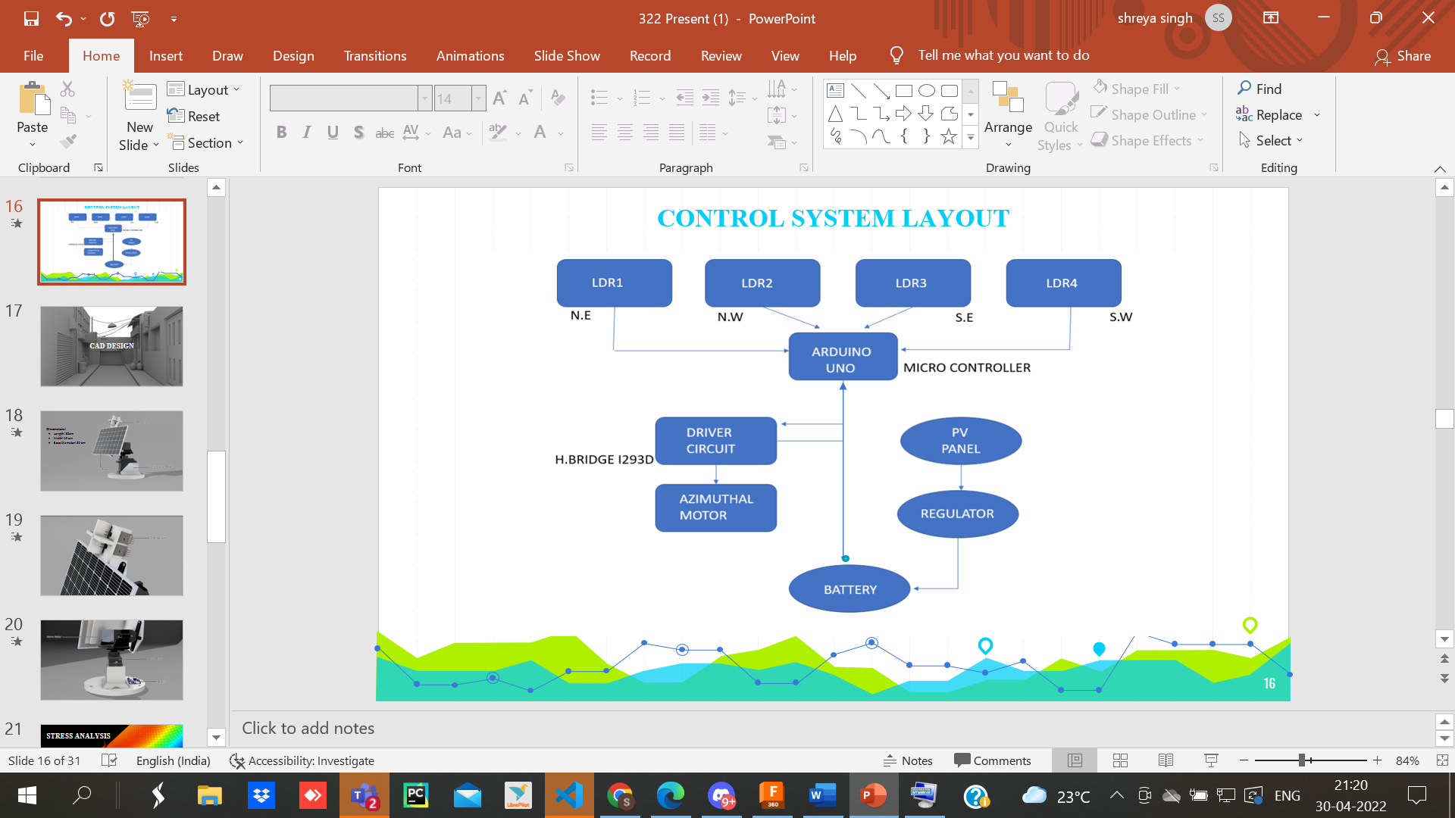

1. **Simulations :**
   1. **Stress Analysis:**

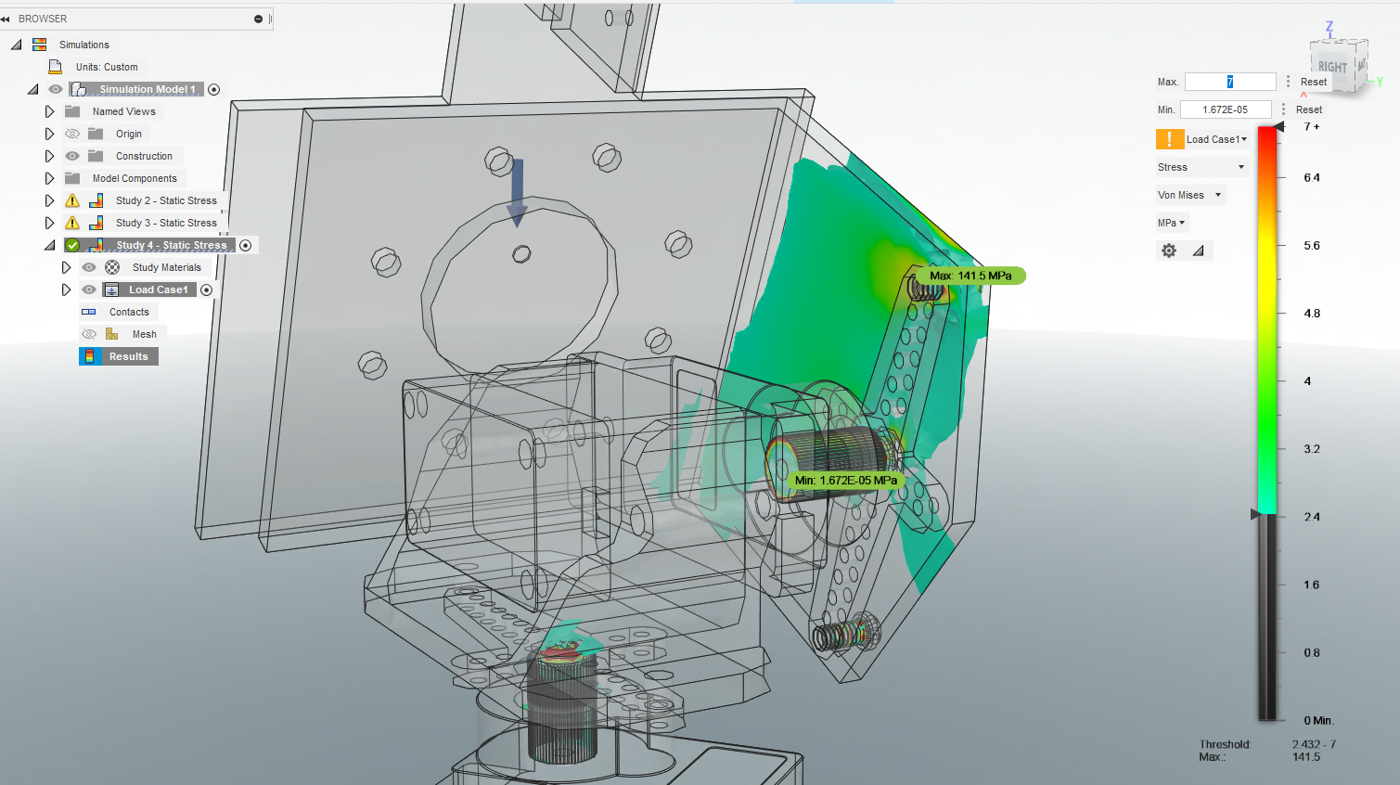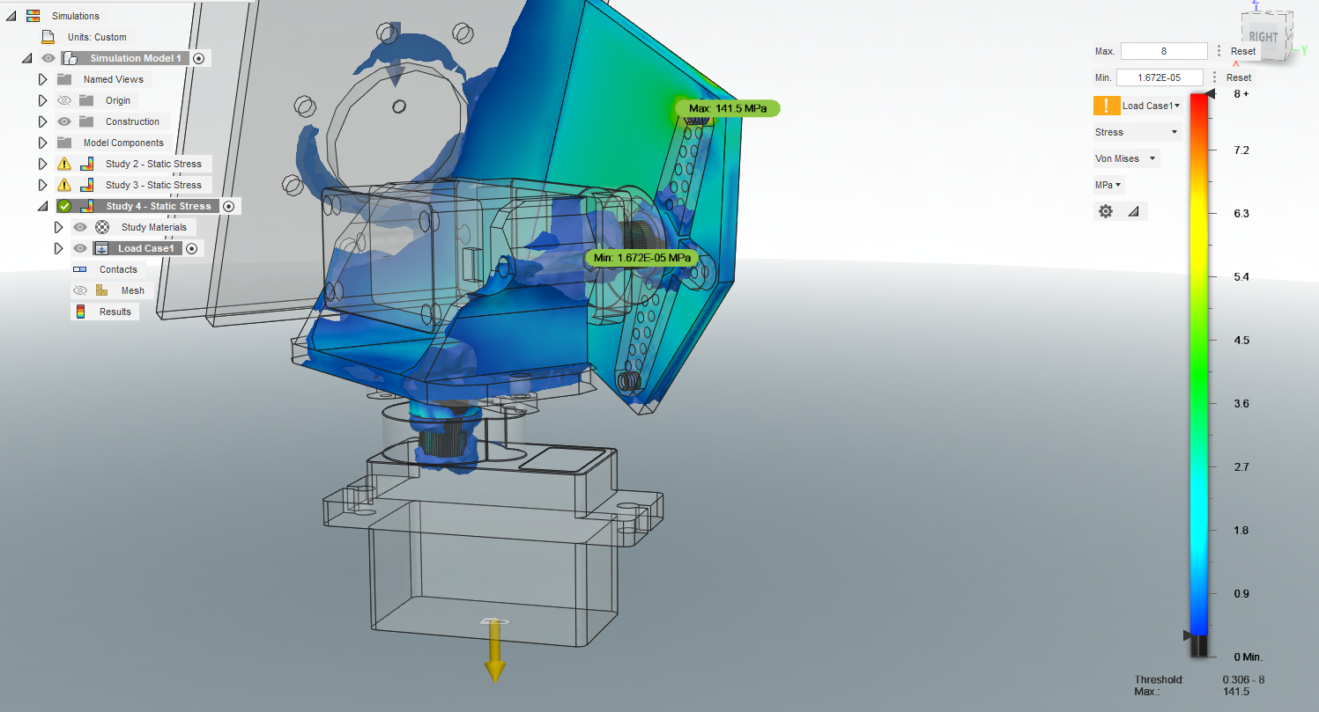

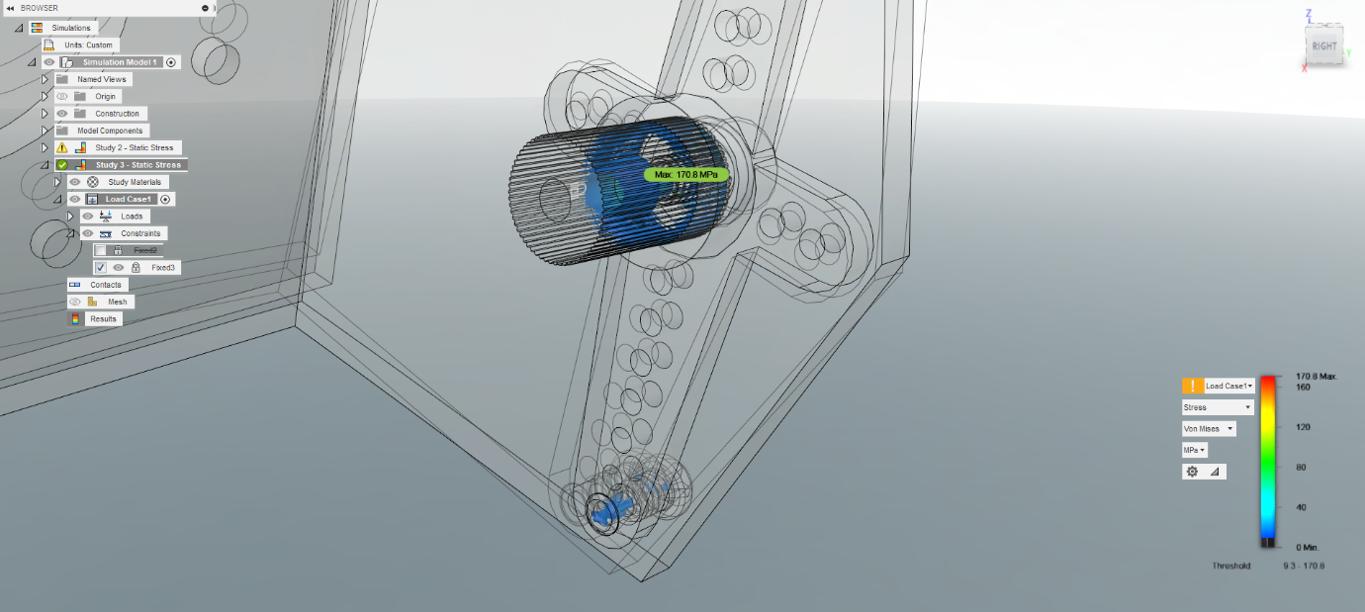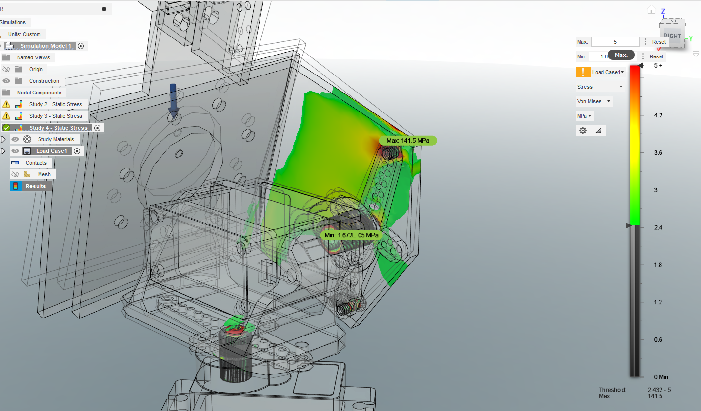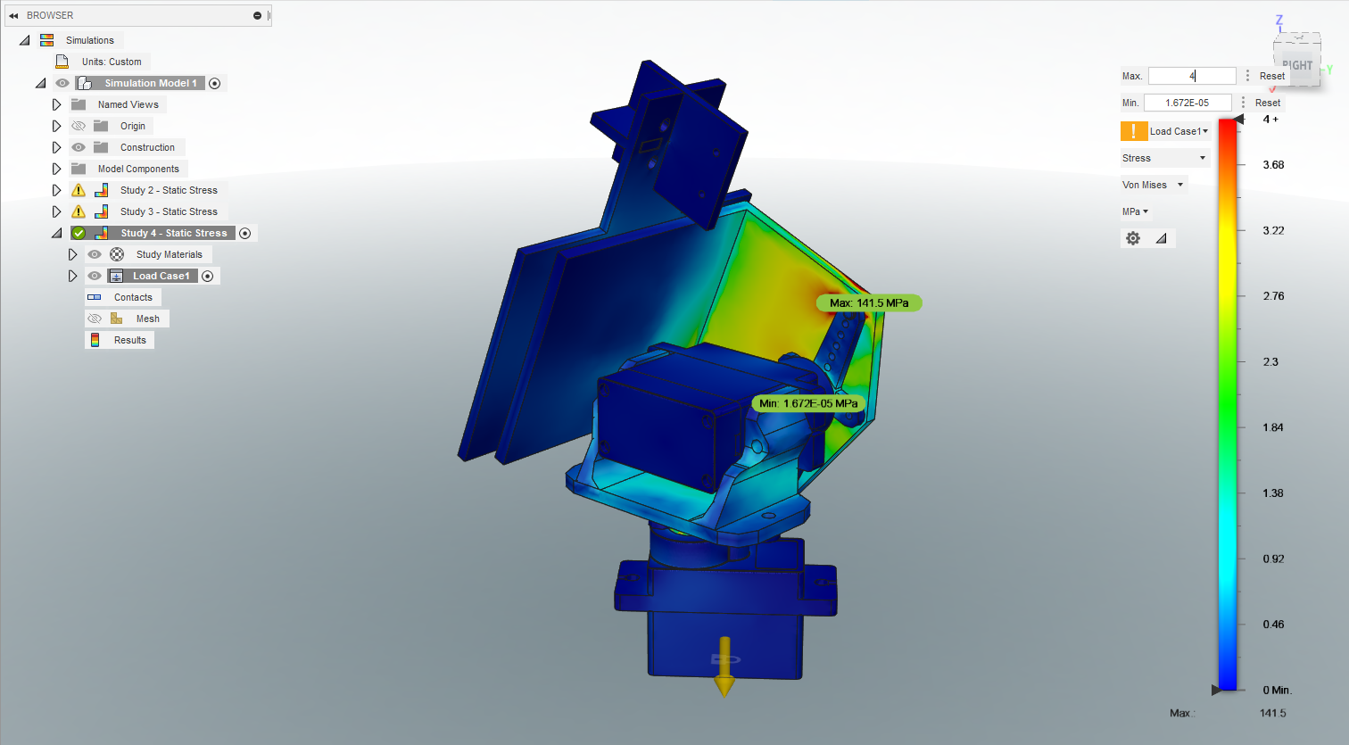

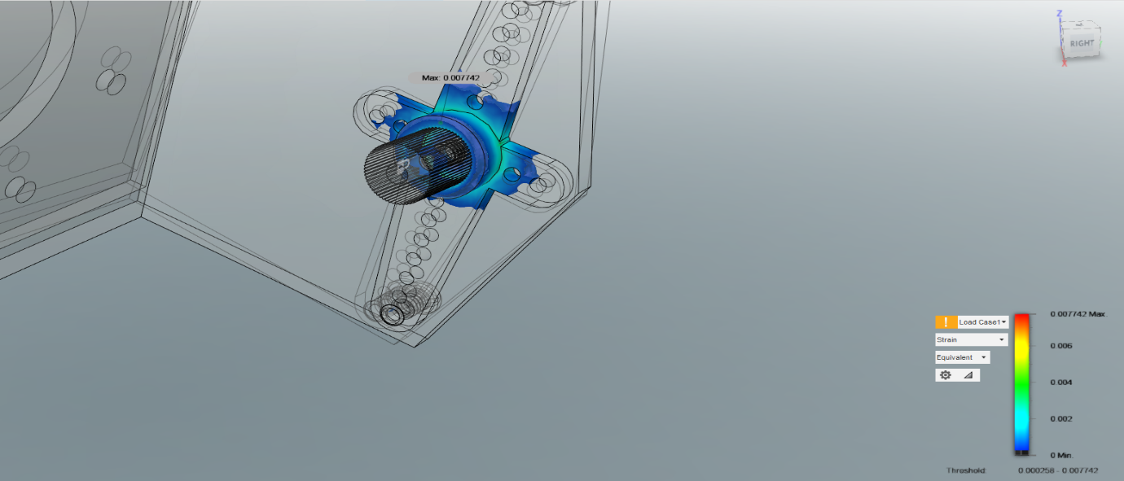

* 1. **Factor of Safety:**

Min factor of safety for our proposed model came out to be 1.463.

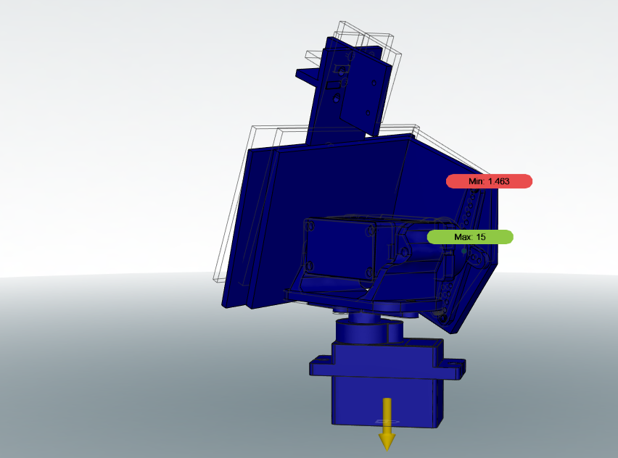

* 1. 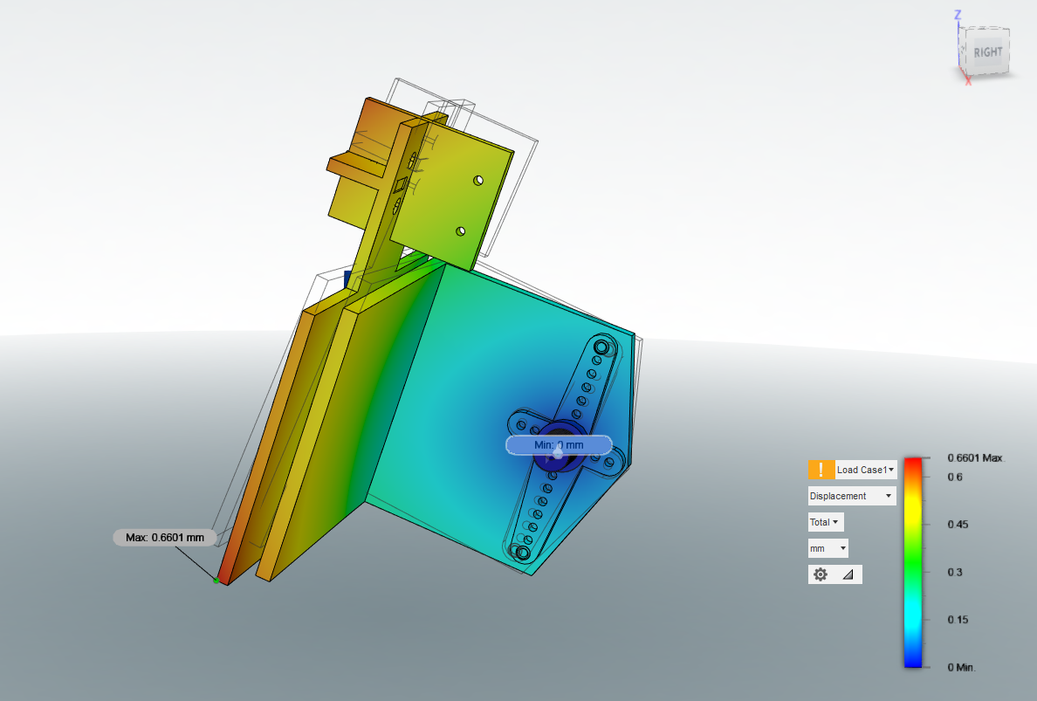**Displacement Analysis:**

1. 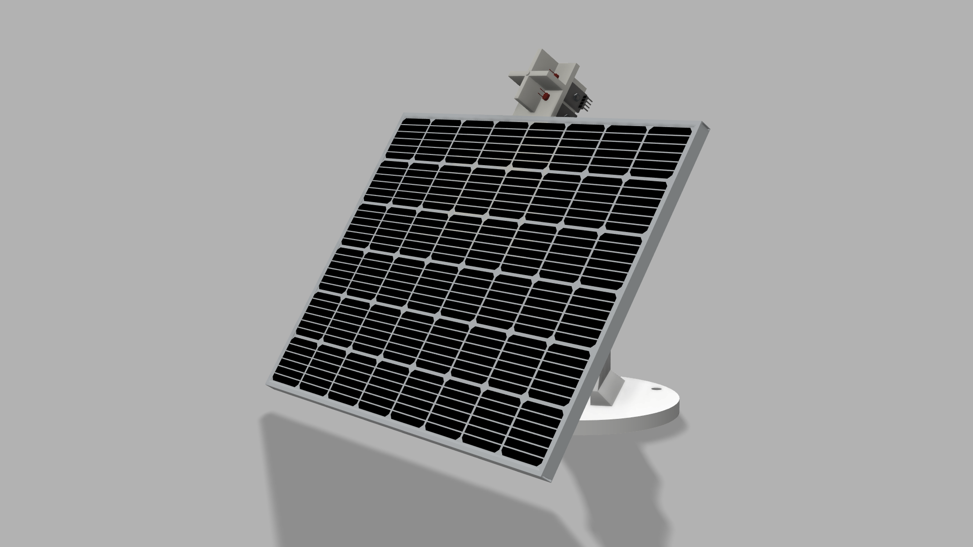**CAD Model :**

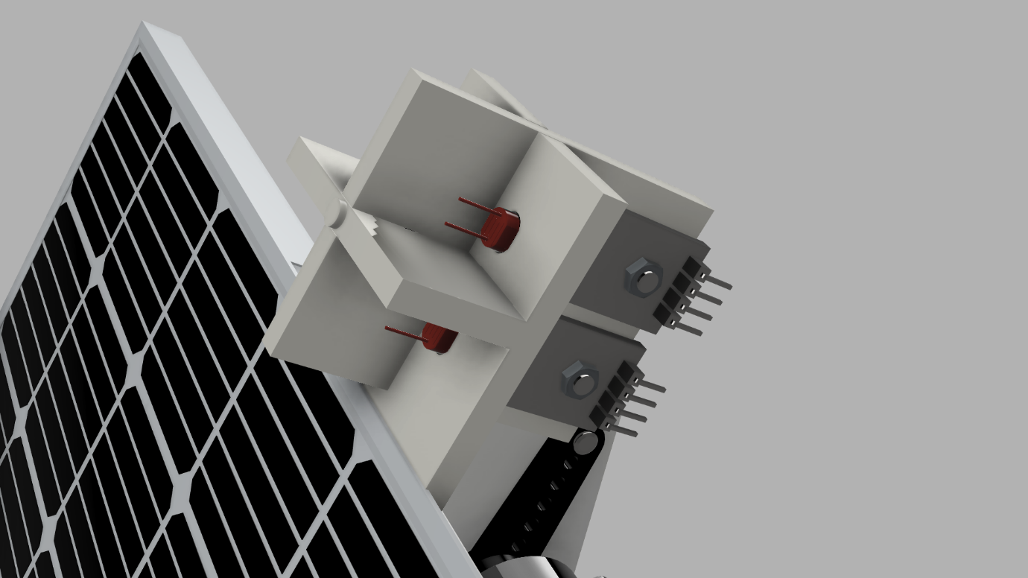

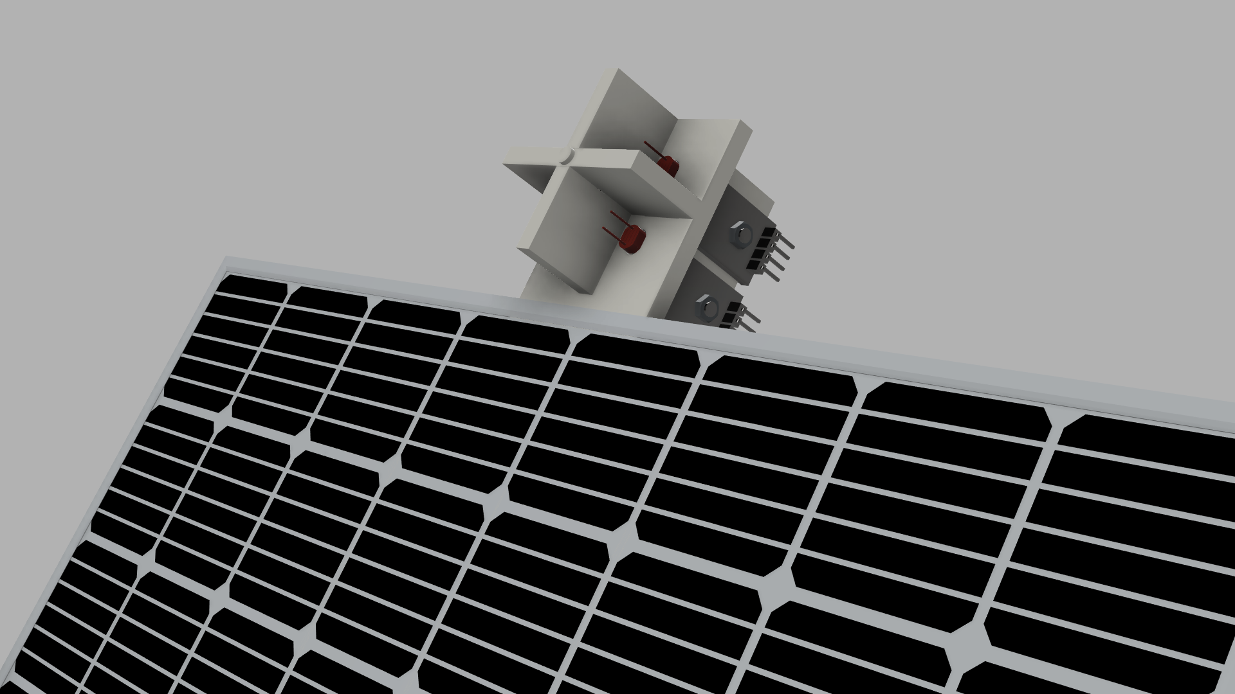

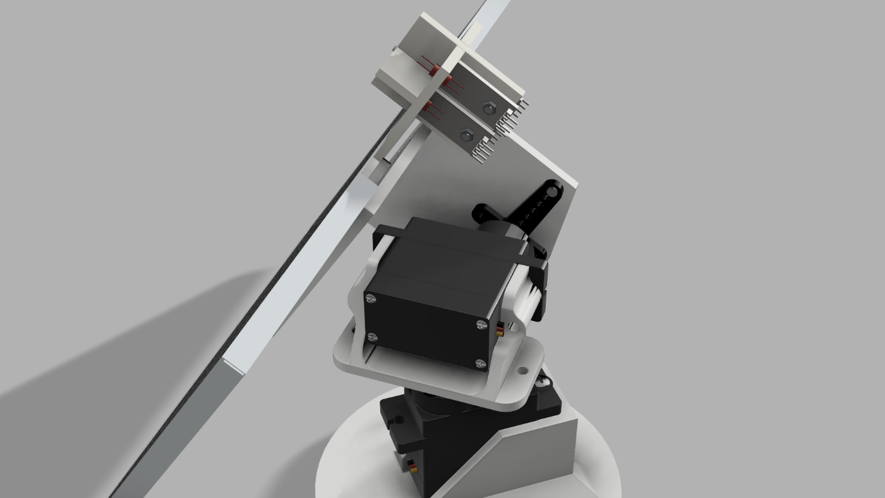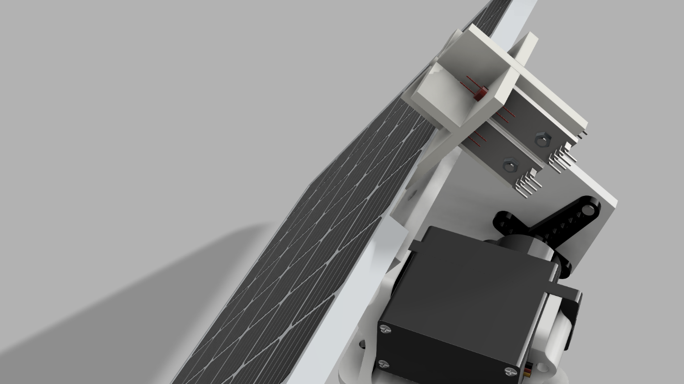

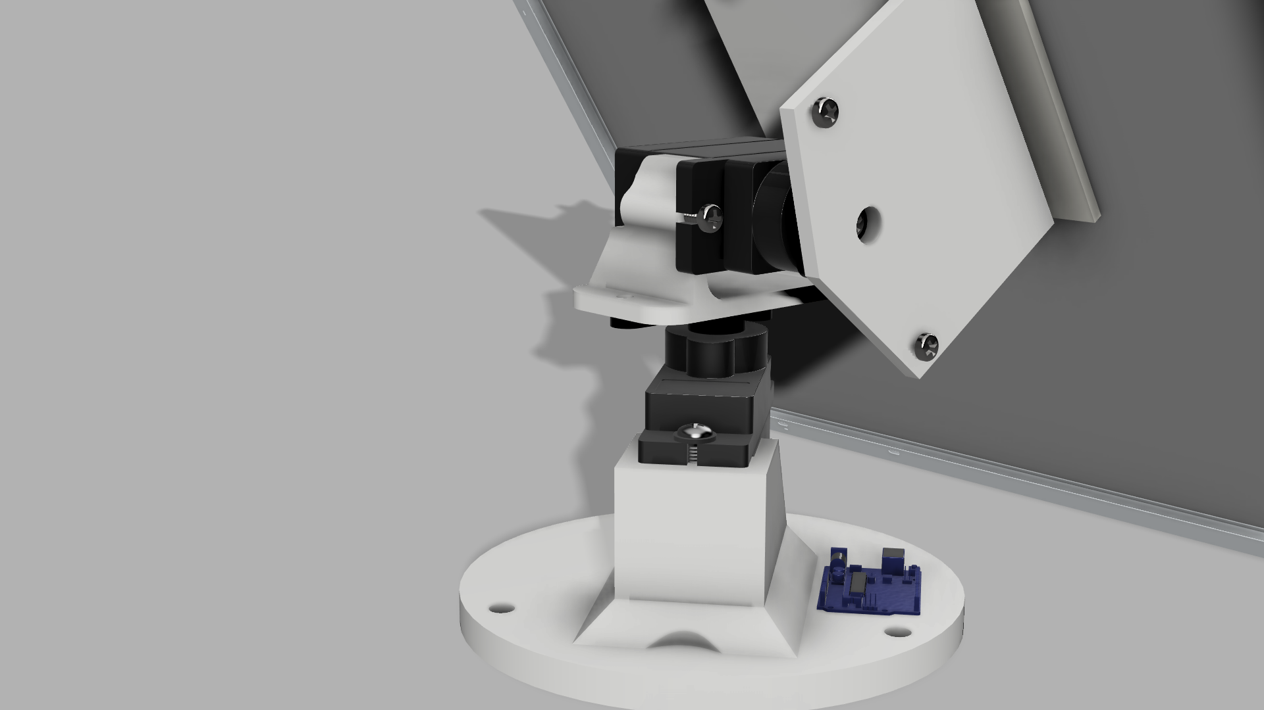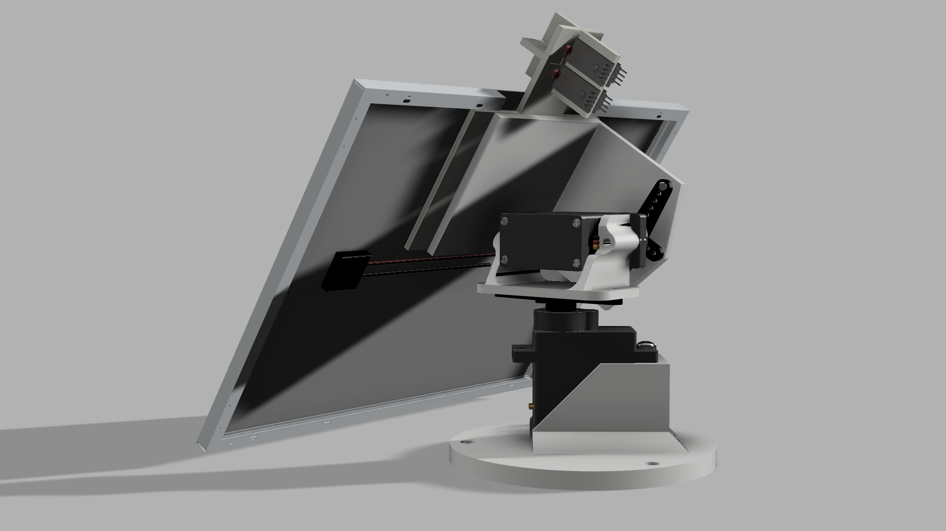

1. **Cost Analysis :**

Approximate cost of all parts of the model have been taken into consideration and a final cost has been predicted for the design which has been tabulated below:

|  |  |
| --- | --- |
| **ITEM** | **COST (In INR)** |
| *Solar Panel* | *3000* |
| *2 X Standard Servo Motor* | *2400* |
| *Arduino* | *800* |
| *4 X LDR Sensors* | *200* |
| *Frame Material* | *800* |
| *Miscellaneous (e.g., Machining, Installation)* | *1000* |
| *Total Cost* | *8200* |

1. **Application / Market :**

Solar trackers have a market size valued at USD 6Billion in 2021 with 8% CAGR. There are several applications in the industry with potential use of solar trackers to increase their efficiency and performance, some of the potential use cases are:

* Orient photovoltaic panels, reflectors, lenses and other devices towards sun.
* Used to collection energy collection grids to maximize energy production by 25-40%.
* Concentrated application like CPV or CSP require higher degree of accuracy to ensure sunlight is directed precisely at focal point of lens or reflector.
* Sun angle changes through years from north to west seasonally, hence we do not have to adjust them manually.
* It’s feasible in hilly and unreachable terrain where establishing electricity infrastructure is difficult.
* It’s best suited for small scale application such as streetlights, solar cookers, etc.

1. **Conclusion :**

We were able to design a self-sufficient Dual-axis solar panel with an active solar tracking mechanism to increase sun exposure resulting in more power generation. The design is simple and practical to use in daily life and hence can definitely reduce the consumption of the vulnerable resources.